**Analyzing Japanese Restaurants in New York**

Brandon O’Grady

February 12, 2021

**1.Introduction**

**1.1 Background**

New York has taken a big hit since the pandemic has started, especially restaurants. Now could be a perfect opportunity for a new restaurant to come in since the rent has lowered and the virus is slowing down.

**1.2 Problem**

To show the location of the top Japanese restaurants and show what location has the highest rating in New York.

**1.3 Interest**

To start a restaurant in New York with the perfect location. Location matters and we want to optimize the location the best we can.

**2. Data acquisition and cleaning**

**2.1 Data sources**

The data source is found from <https://cocl.us/new_york_dataset> and used with ForSquare to locate all Japanese restaurants.

**2.2 Data Cleaning**

Data was import into Jupyter Notebook and combined with ForSquare to receive all information about the restaurants. The columns were then renamed to our liking and printing into a table.

**3. Exploratory Data Analysis**

**3.1 Neighborhoods per Borough**

First, we needed to see how many neighborhoods per Borough in New York there were. We discovered that Queens has the highest at 80 neighborhoods and Manhattan has the lowest.

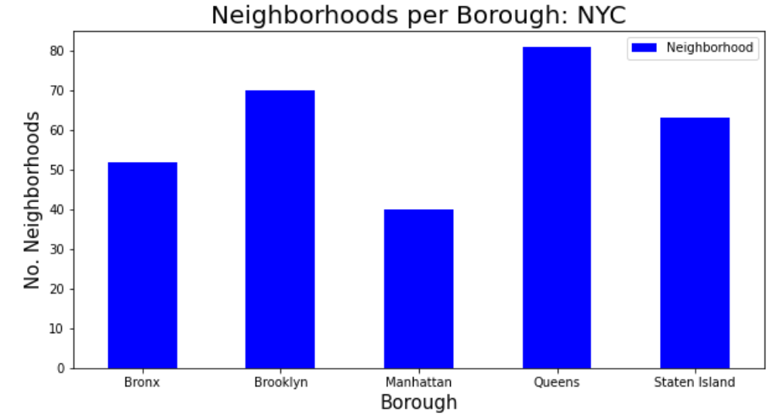

**3.2 Japanese Restaurant per Borough**

We then analyzed to see how many Japanese restaurants there were per Borough. We discovered that Manhattan has the most Japanese restaurants per Borough.

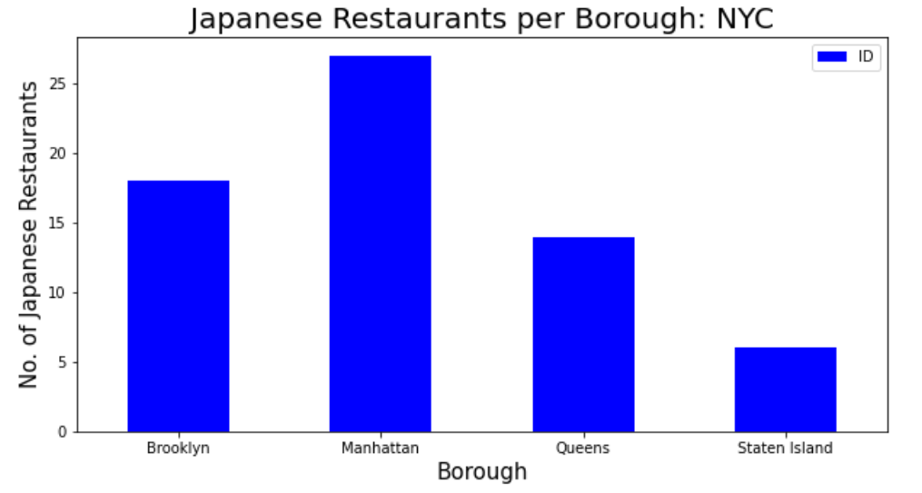

**3.3 Average Rating of Japanese Restaurant for each Borough and Neighborhood**

Now we need to compare what location could be the best location for us to open up a new restaurant comparing the average rating. We see that Brooklyn and Manhattan has the highest average rating for Borough and East Village, Cobble Hill, and North Side has an average rating of 9 or higher per neighborhood.

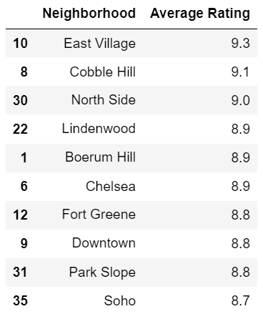 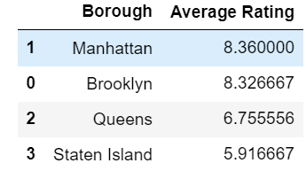

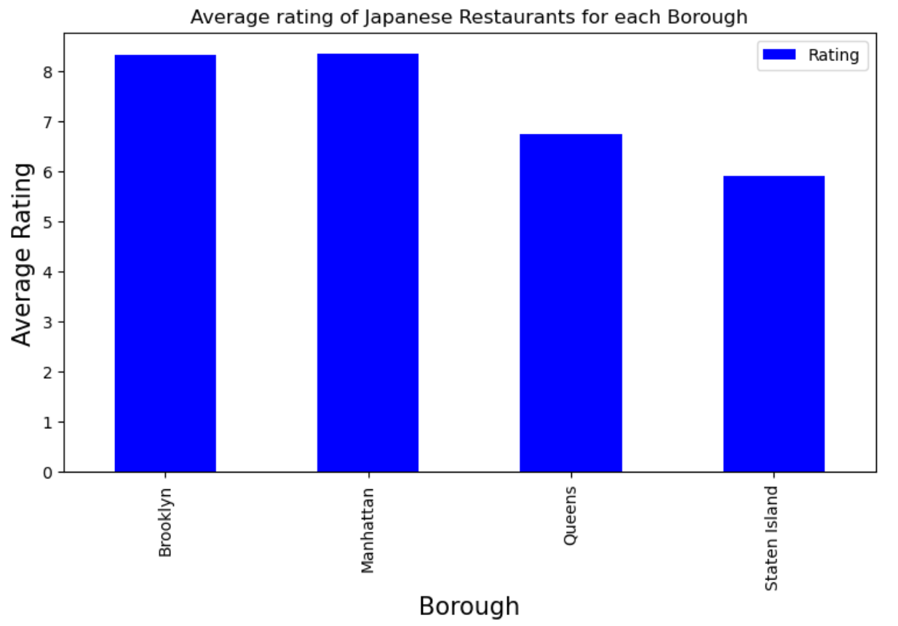

**3.4 Visual Map**

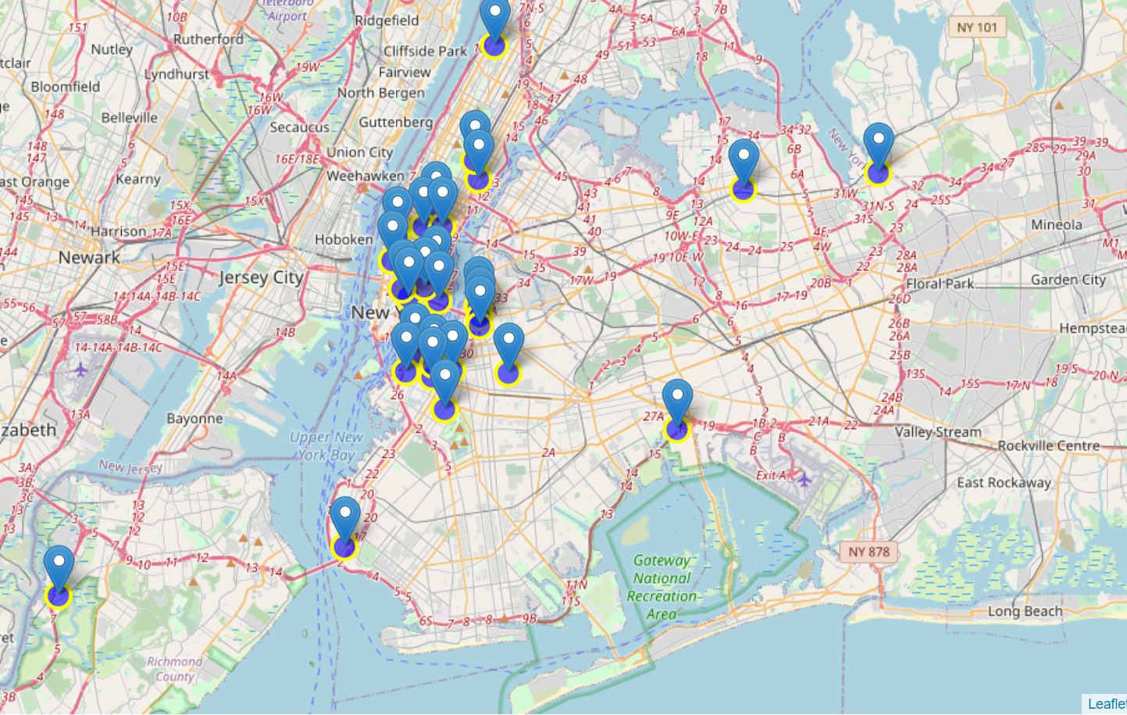

**4. Conclusion**

Now that we have a clear understand where the popular restaurants are located, we can discuss where we want to place our new restaurant. We way not want to place it near these popular places because it may be though to compete with them. We also have a visual of all the restaurant so we could place it were there is not a Japanese Restaurant located.